- \Operation\Basic settings\Reference offset values
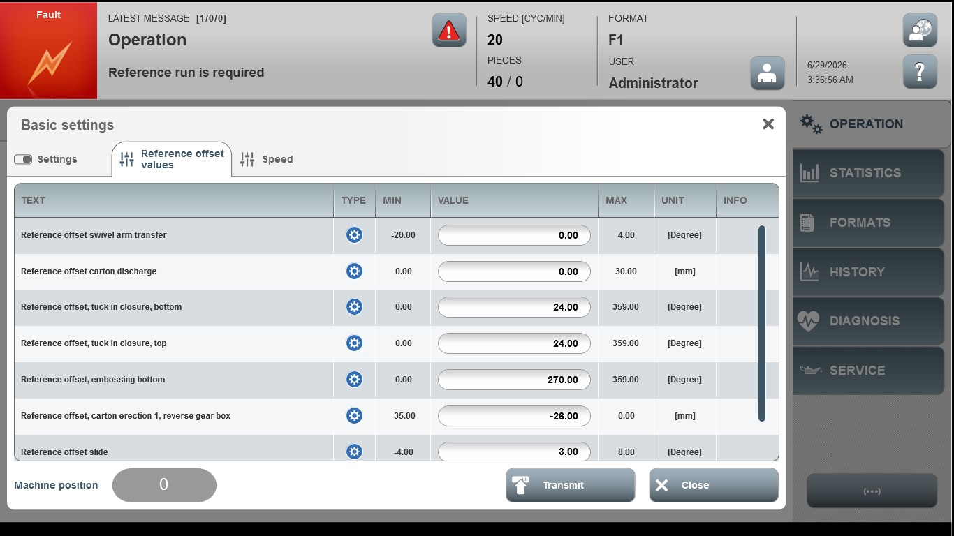
Acceptance criterion | Limits | Pass / Fail: Dev-No. | Date | Initials
Screen matches screenshot | N / A
Reference offset swivel arm transfer | -20.00 ... 4.00
Reference offset carton discharge | 0.00 ... 30.00
Reference offset, tuck in closure, bottom | 0.00 ... 359.00
Reference offset, tuck in closure, top | 0.00 ... 359.00
Reference offset, embossing bottom | -35.00 ... 00.00
Reference offset, carton erection 1, reverse gear box | -35.00 … 10.00
Reference offset slide | -4 ... 8.00

